Jumpree by Smarten Spaces for Microsoft Teams: Deployment Guide
Jumpree by Smarten Spaces is well integrated with Microsoft Teams. This guide walks through the steps an IT admin needs to take to deploy the app for users in their organization.
With Jumpree by Smarten Spaces, employees can exercise a host of options with ease, without the need for any additional app downloads.
- Set up Work Status by selecting the days they work from office,
- Work in Collaboration by Synchronizing schedules with colleagues,
- Book Any Spaces that best suit their requirements across meeting and collaboration spaces, desks, and other amenities or any spaces across the office, Deployment uidance for IT admin

Prerequisites -
- Active Microsoft 365 subscription
- Active Jumpree by Smarten Spaces Subscription
  - Go to the Microsoft Teams store
  - Search for Jumpree by Smarten Spaces
  - Buy a subscription
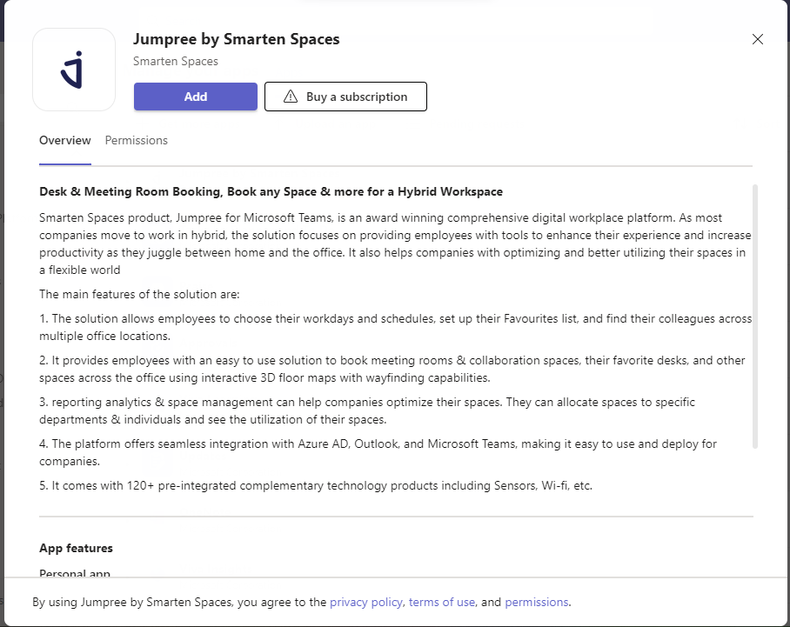

  - Choose a Subscription Plan and Checkout
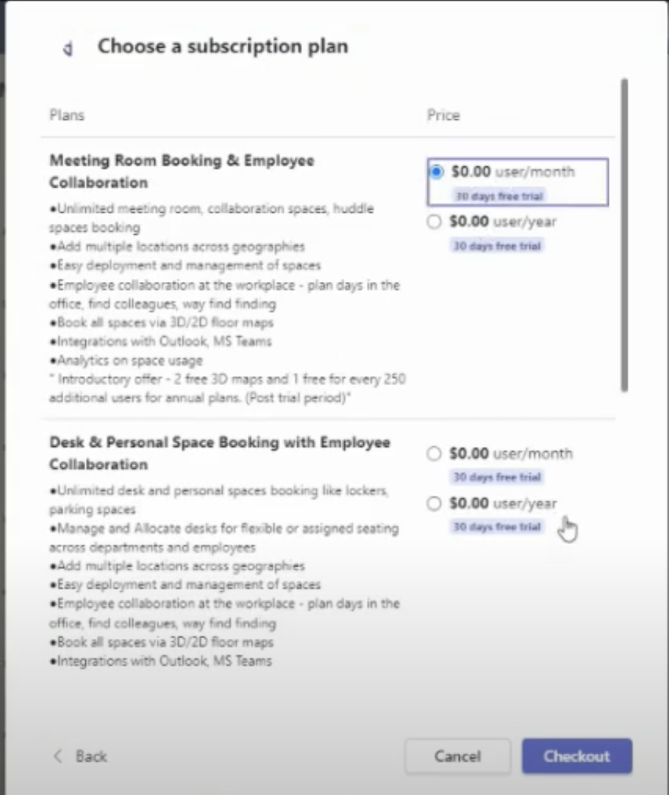

  - Enter the number of users and Place Order
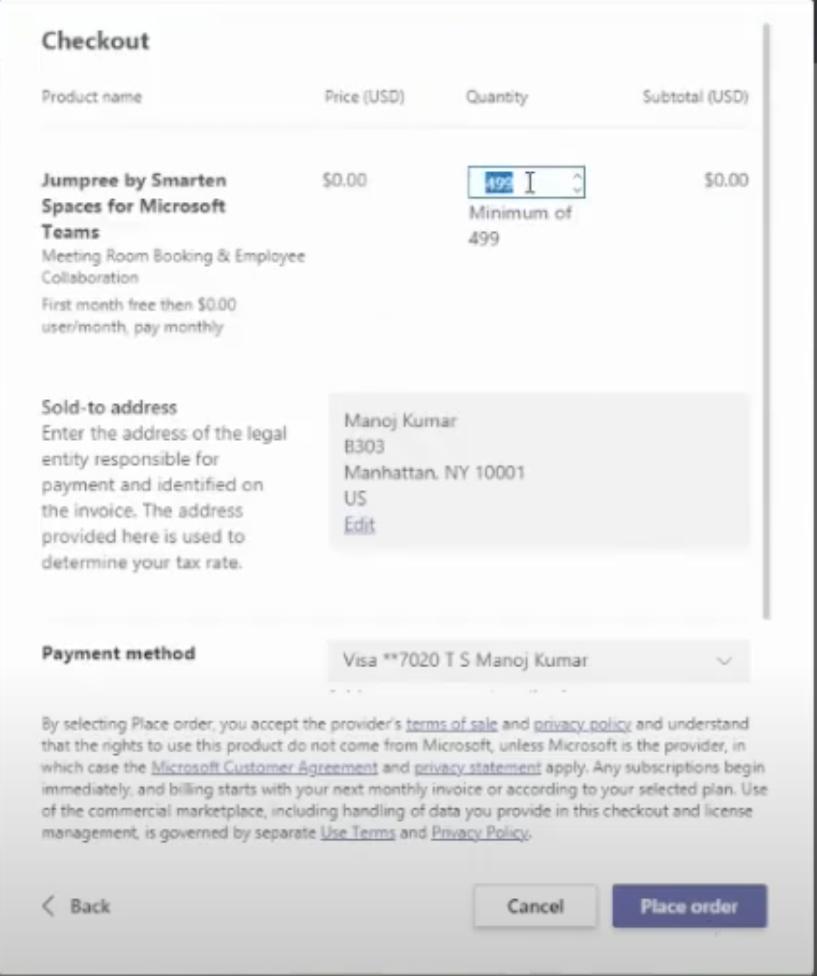
  - Once on the landing page, fill up the details as asked for and click on submit
  - The Platform is then deployed within minutes and thereafter the Admin can setup the solution.

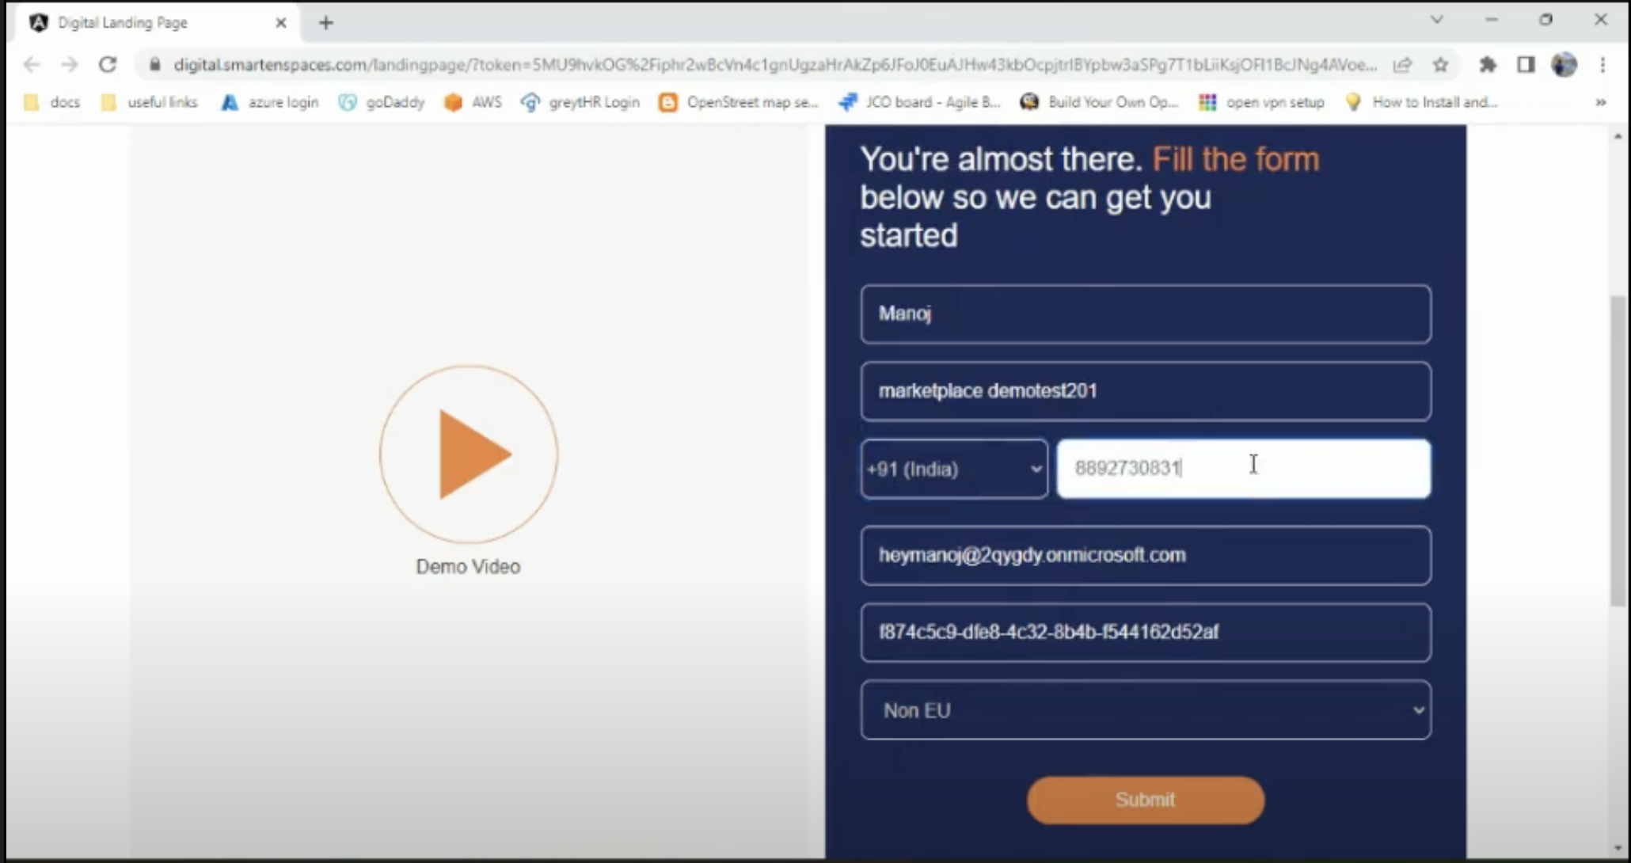

Architecture and line of business customization
The Jumpree by Smarten Spaces product has a desktop and app version. The desktop version has all the features for all the roles and is predominantly used by the Global and Super Admin as many of the activities need large screens for e.g., floor plan onboarding capability etc. The app interface is primarily for general users and gives an enhanced experience. The platform seamlessly integrates with M365 (for Meeting Room Bookings) & Microsoft Teams (for Video Conferencing Link generation). Users are automatically logged into the Jumpree with their AD Credential/session.

Troubleshooting
KEY USER JOURNEYS FOR GLOBAL ADMIN
*Any user mapped to the Global Admin role automatically becomes the Super Admin and general user for all onboarded locations

- Global Admins can shuffle between a Super Admin role by clicking on the display icon on the top right corner of the screen.

- Onboard Users and map licenses
- Global Setup
- Add Multiple locations across geographies.
- Users are selected from AD where department information is collected.

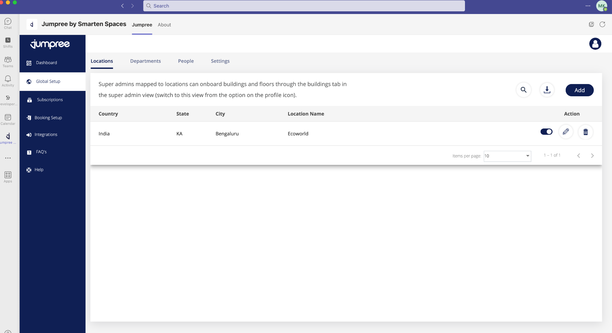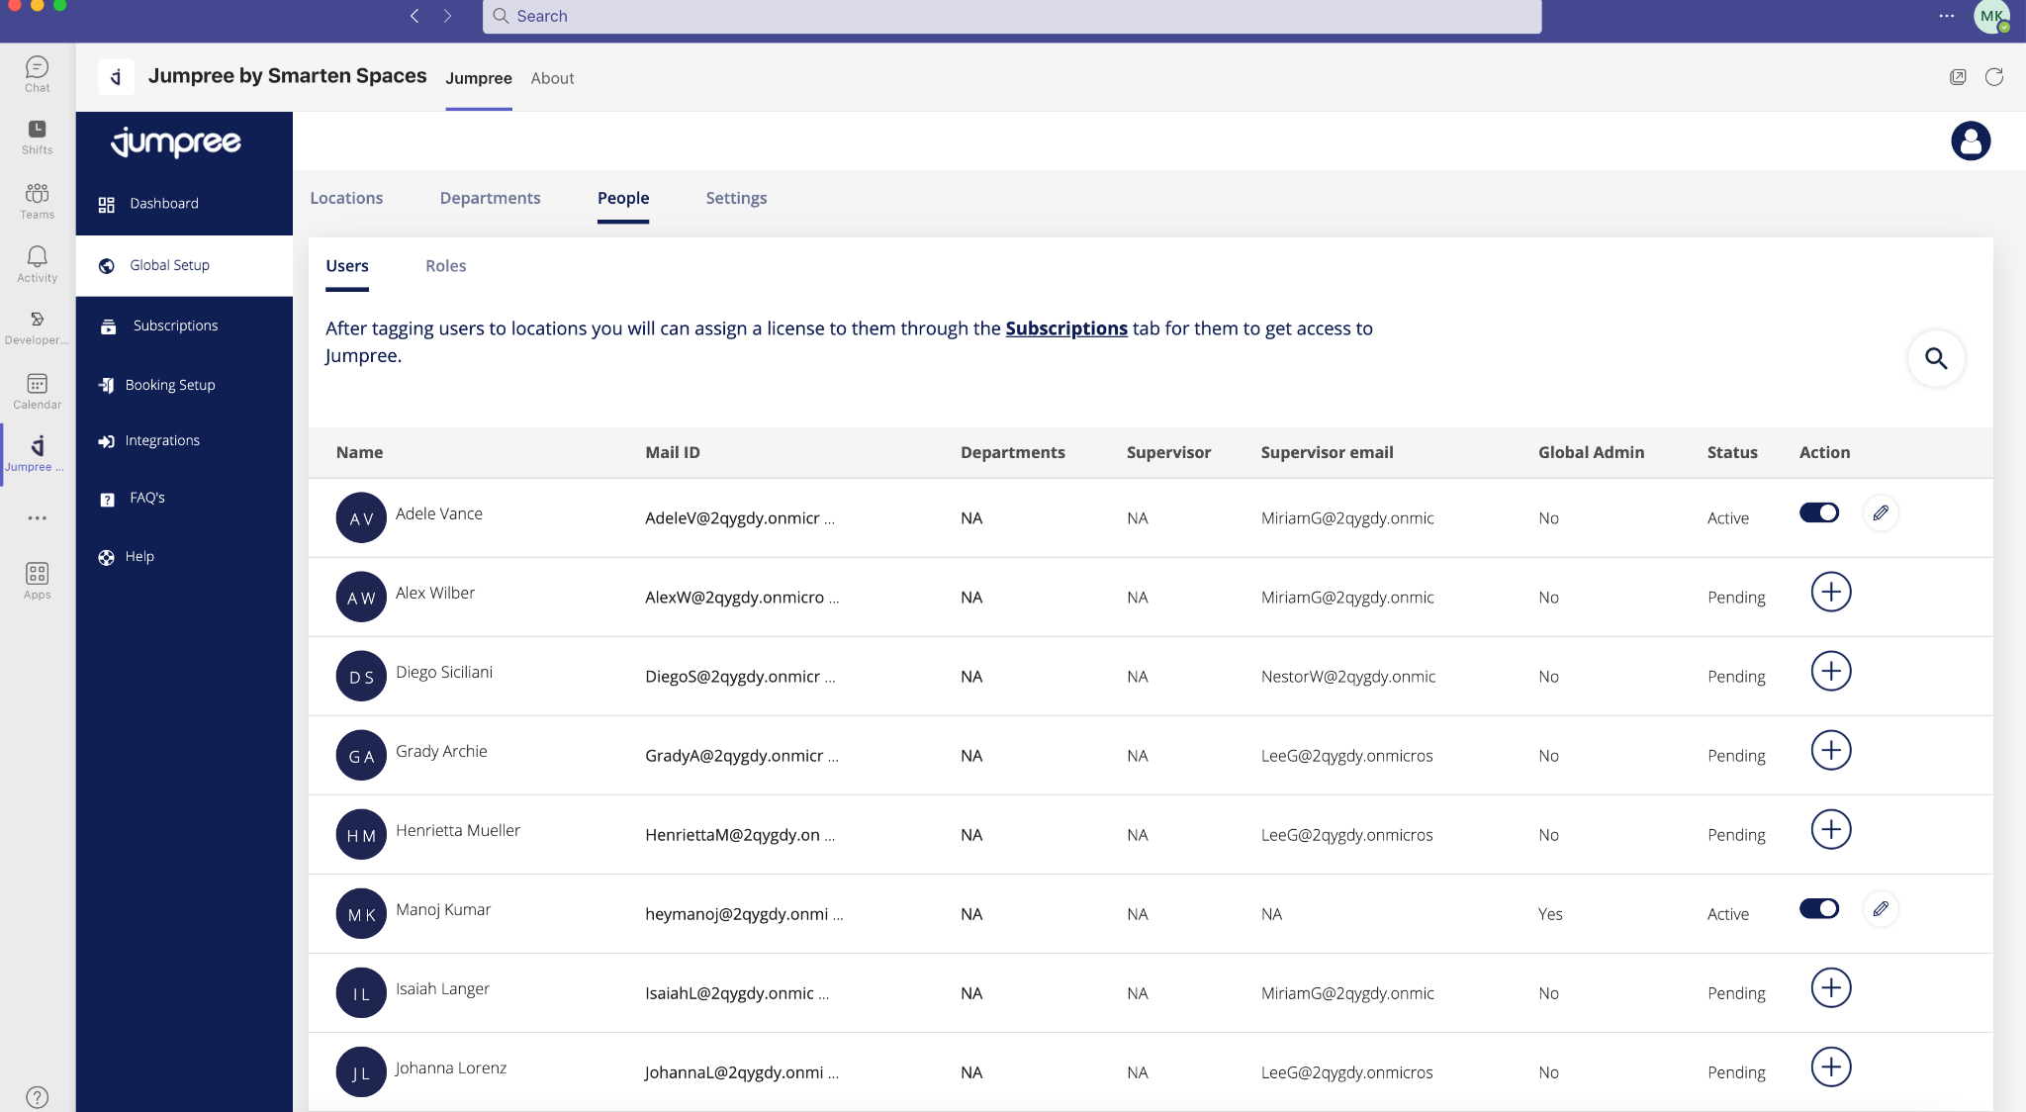

- Subscription Onboarded users need to be mapped to a license in the subscription tab to get access to the solution.
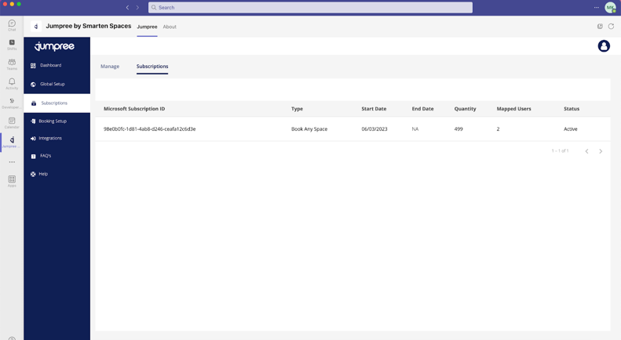
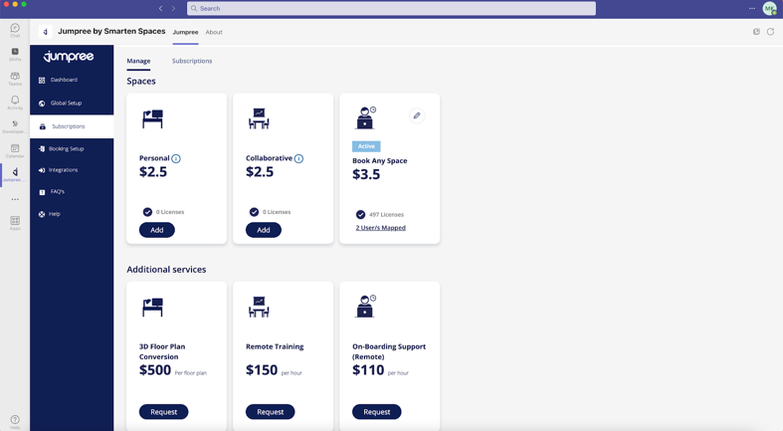

- Activate spaces, globally.
- The Global Admin can activate a default space or add a new space or delete a space based on the purchased subscription.
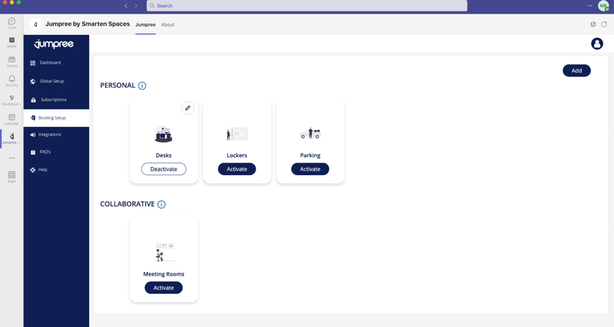
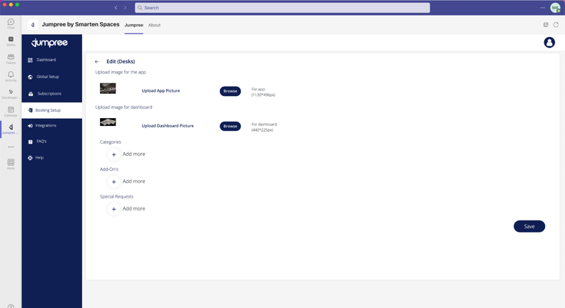

- Setup Integrations (Please note that this is purely a section for integration for the target customers)
- Office365 Calendar - this integration helps integrate with Office365 for Meeting Room Bookings & can then be enabled at a location level based on the preference of the super admin at that location.
- Teams Video Conference Link – This integration helps Users to optionally create Teams VC Link while booking a Meeting Room.

- The dashboard tab gives an overview of all global actions.
- KEY USER JOURNEYS FOR THE SUPER ADMIN
- The Super Admin can be mapped to a single or multiple locations by the Global Admin. They automatically become general users for the mapped location(s).
- A Global Admin could switch to a ‘Super Admin’ view by clicking on the “User Icon” at the top right corner & by using “Switch to Super Admin” button.
- Super Admin can change their locations (in case they are mapped to many) by selecting the location dropdown present on the top right corner of the desktop screen.

- Onboard Buildings and Floors
- By clicking on the buildings tab, the Super Admin can add multiple buildings and subsequent floors and can arrange the sequence.
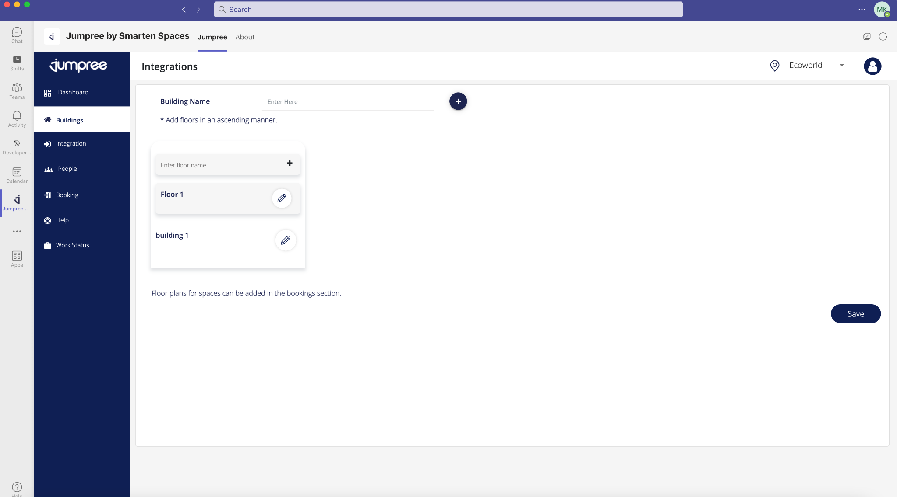
- Booking
- The Super Admin can enable space(s) relevant to the location and start the setup process.
- Setup button - selects categories, add-ons etc.
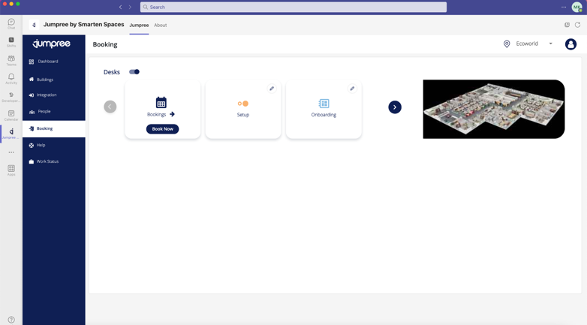
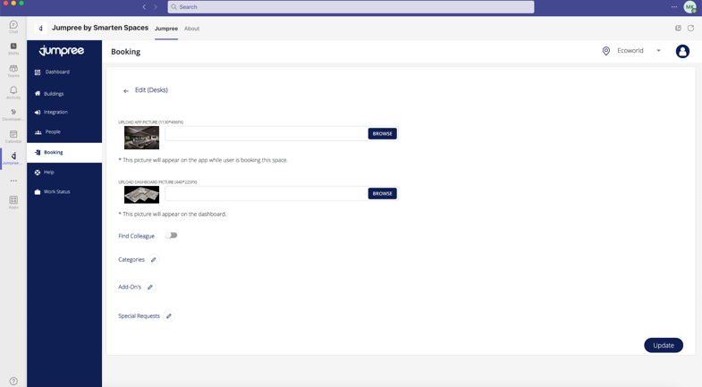

- Click on the onboarding button - mention bullet points on the onboarding flow.
  - Add the Floor Plan
  - Identify the spaces that need to be onboarded.
  - Once identified, you can adjust the zoom levels and the pointer size.
  - Select the spaces identified to onboard.
  - If required, you can change the names.
  - Once selected, you can then map the categories, add-ons, special request and capacity (for Collaborative Spaces) to it
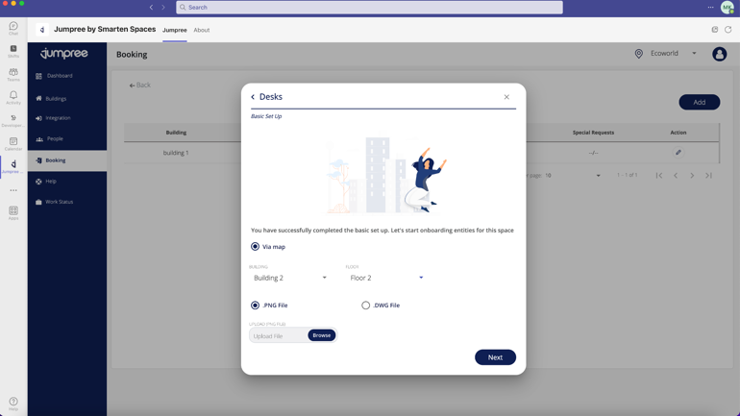
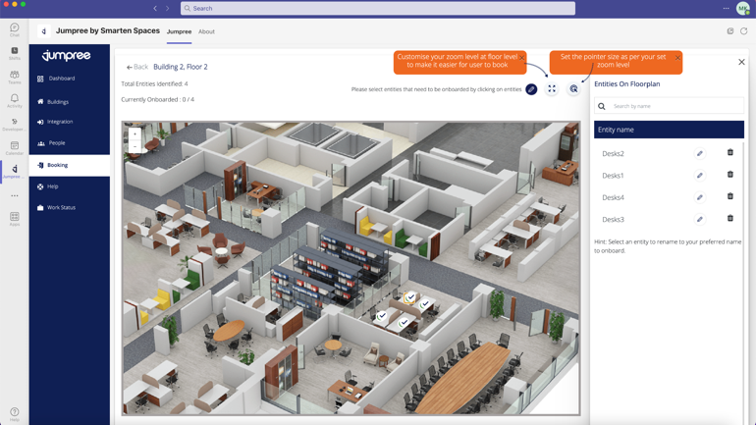
  - Post this you can configure the wayfinding if required.

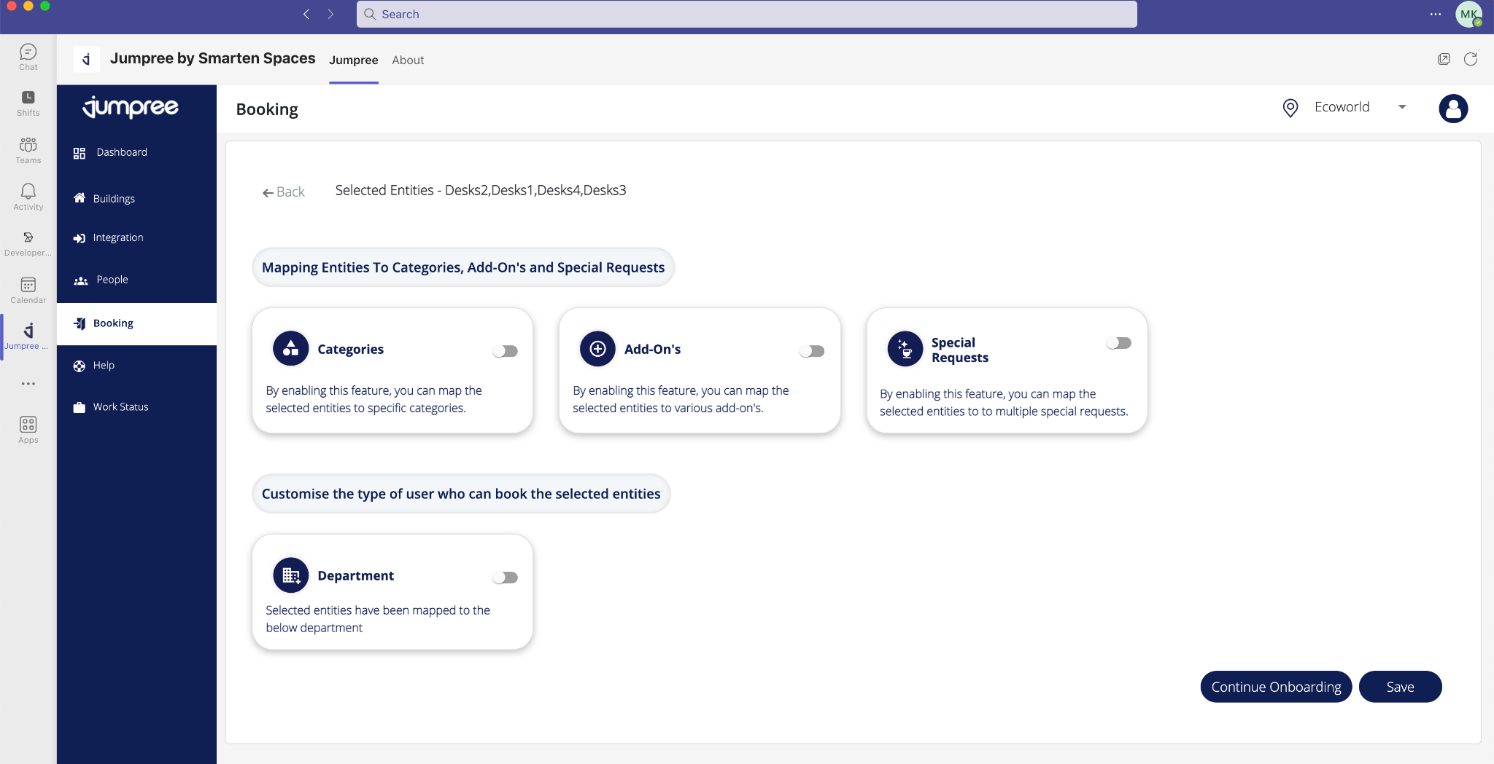
- Settings – Configurations that defines user booking experience for that Space & location.
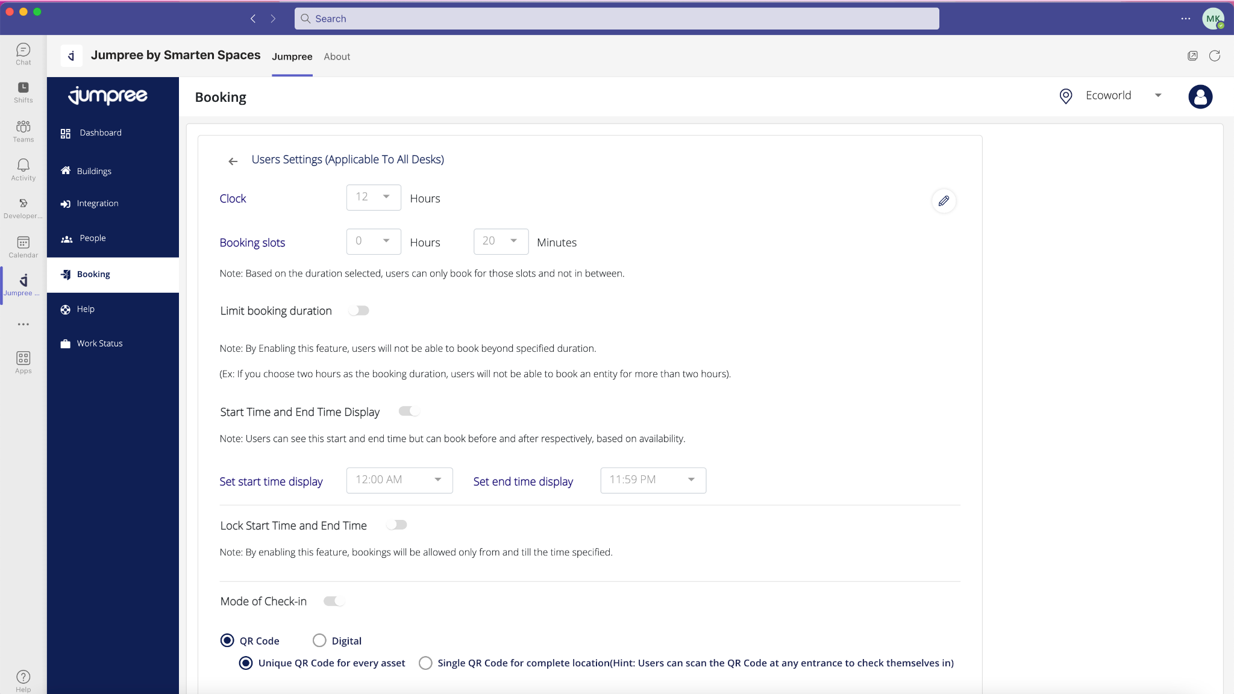

- Analytics – Shows the Booking Trends, Counts & User behavior for the Space.

- Configure Integrations
- Select relevant integration for the onboarded spaces.

KEY USER JOURNEYS FOR THE GENERAL USER
- Home Screen
  - The user on the home screen can choose their work status (Leave, Office or Home) as well as select their location.
  - On the Quick Actions, the end user can see all their bookings (Meeting / Rooms, Parking etc.). They can also check-in from there as well as way-find towards their Room / Desk) as well as join a meeting virtually.
  - My Favorites: End users can see their colleague’s work status as well as if they have booked a desk, see their desk no. Users can create a “favorite” list of their colleagues.

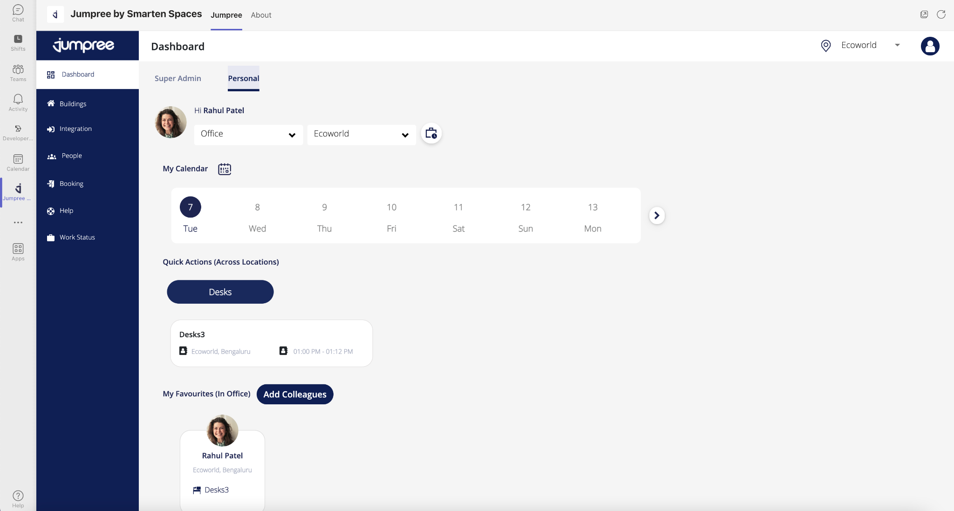

- Booking
  - Via the Bookings tab, users can do bookings of space as on boarded by the Admin. They could be Personal spaces like desks / parking / lockers or Collaborative Spaces like Meeting Rooms, Huddle Room etc.
  - Personal Spaces Like Desk, Lockers, Parking etc.
    - To book a Personal space like Desk, users can click on Desk Booking, post which a floor map opens.
    - If required users can filter based on the amenities on the desk (like Ergonomic chair, Phones etc.) and choose their time.
    - Users can select an available (green) desk and book the desk.
    - The desk booking is complete which gets added in the booking history as well as in quick actions.
    - Once the desk is booked user has the option to cancel their bookings
    - Users can also way-find from the point of entry towards the desk they have booked.
    - If enabled by admin, users need to check-in to their desk by scanning a QR code. If not checked-in within a certain time, the desk gets released.
    - Option to do multiple days /recurring booking via the calendar view. This comes with floor plan recommendations.
    - Users can search for a desk, and based on availability book that desk.
    - Via the Preference tab, users have an option to display their desk no. to either “All”, “None”, “My Department” or “Custom”.
    - Find Colleague: Users can search for their colleagues. They can see the days when they are coming to the office, the desk they have booked as well as way-find to exactly where their desk is. Additionally, they can book a desk next to their colleagues.
  - Collaborative Spaces Like Meeting Rooms, Huddle Rooms etc.
    - To book a Collab space like Meeting Rooms, users can click on Meeting Room Booking, post which a floor map opens.
    - If required, users can filter based on the amenities of the rooms (like Projectors, VC Unit, Capacity etc.) and choose their time.
    - Users can select an available (green) room. User then enters the “Title”, Add Participants, select a Video Conferencing link and book the room.
    - The room booking is complete which gets added in the booking history, Outlook calendar as well as in quick actions.
    - Once the room is booked user has the option to cancel their bookings
    - Users can also way-find from the point of entry towards the room they have booked.
    - If enabled by admin, users need to check-in to their room by scanning a QR code. If not checked-in within a certain time, the room gets released.
    - Option to do multiple days /recurring booking via the calendar view.
    - Users can search for a room, and based on availability book that room.

  - Work Status
    - Via the work status tab, users can choose the days they are working from the office, home or are on leave.
    - Users can also choose if others can see their work from home status / leave status. By default, work from the office is displayed.

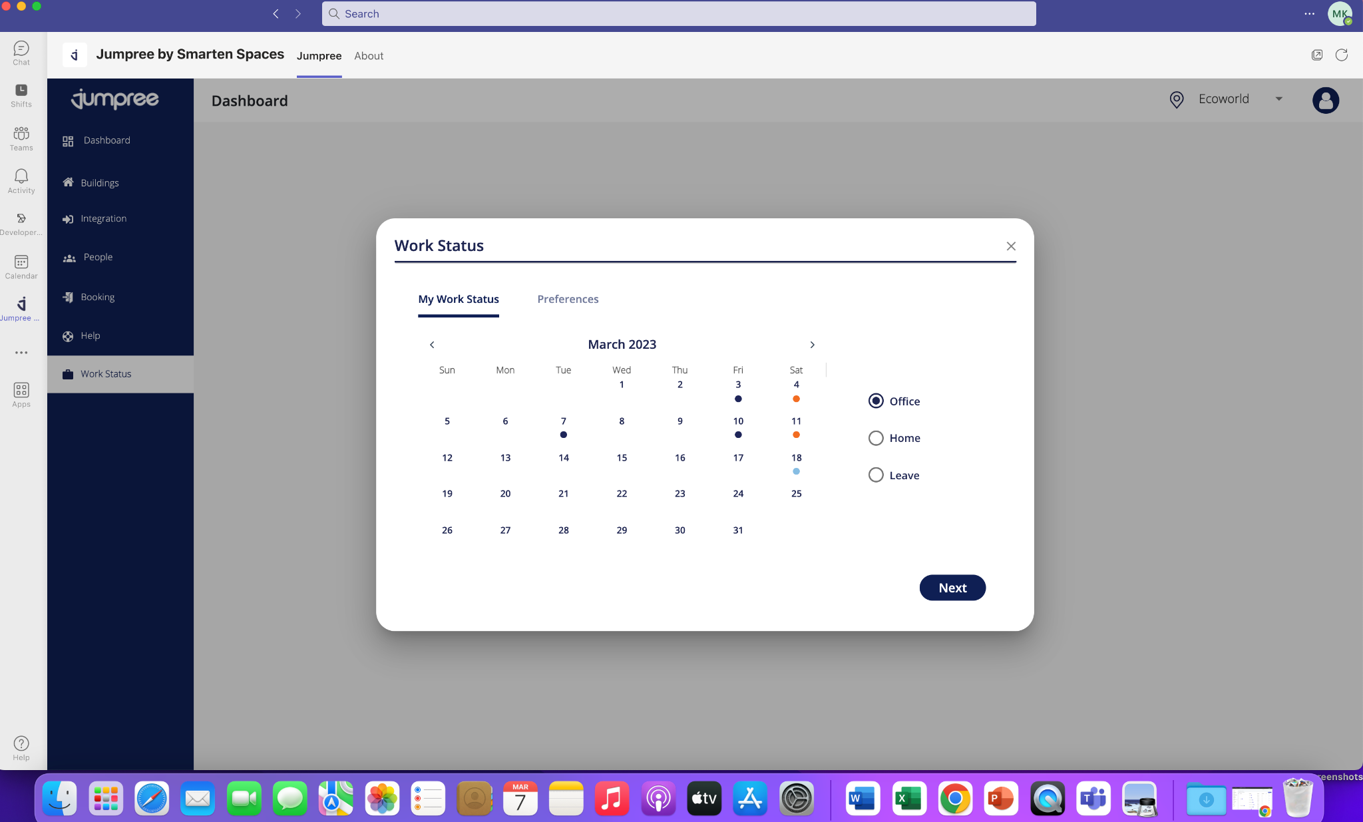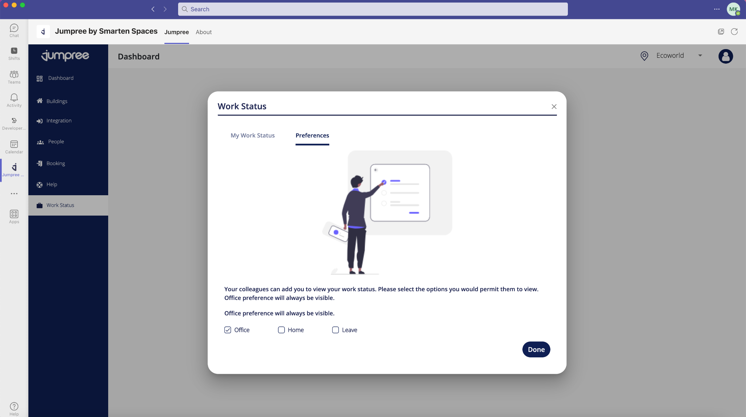

- Check a colleague's work status.

Technical support contact information
• For additional assistance, email support@smartenspaces.com

